**HO CHI MINH NATIONAL UNIVERSITY**

**University of INFORMATION TECHNOLOGY**

**FACULTY OF INFORMATION SYSTEMS**

**FINAL PROJECT**

**INFORMATION SYSTEMS ANALYSIS AND DESIGN**

**PROJECT**

**VISITVIETNAM**

**Class:** MSIS3303.L21.CTTT

**Instructor:** Master Trinh Trong Tin

**Student list:**

1. Dang Quoc Khoa 18520911

2. Do Hoang Hiep 18520726

**Ho Chi Minh city, June 18th 2021**

**INSTRUCTOR COMMENTS**

**………………………………………………………………………………………………………………………………………………………………………………………………………………………………………………………………………………………………………………………………………………………………………………………………………………………………………………………………………………………………………………………………………………………………………………………………………………………………………………………………………………………………………………………………………………………………………………………………………………………………………………………………………………………………………………………………………………………………………………………………………………………………………………………………………………………………………………………………………………………………………………………………………………………………………………………………………………………………………………………………………………………………………………………………………………………………………………………………………………………………………………………………………………………………………………………………………………………………………………………………………………………………………………………………………………………………………………………………………………………………………………………………………………………………………………………………………………………………………………………………………………………………………………………………………………………………………………………………………………………………………………………………………………………………………………………………………………………………………………………………………………………………………………………………………………………………………………………………………………………………………………………………………………………………………………………………………………………………………………………………………………………………………………………………………………………………………………………………………………………………………………………………………………………………………………………………………………………………………………………………………………………………………………………………………………………………………………………………………………………………………………………………………………………………………………………………………………………………………………………………………………………………………………………………………………………………………………………………………………………………………………………………………………………………………………………………………………………………………………………………………………………………**

**TABLE OF CONTENTS**

Part I. INTRODUCTION 1

1. BUSINESS PROFILE 1

1.1. Abstract: 1

1.2. Project purpose: 1

1.3. Project functions: 1

1.4. Product: 2

1.5. Services: 3

1.6. Customers: 4

1.7. Competitors: 4

1.8. Constraints: 4

1.9. Future direction: 4

2. PROJECT SURVEY 4

2.1. Survey plan: 4

2.2. Input: 5

2.3. Related project: 5

2.4. Compare these projects: 6

Part II. REQUIREMENT SPECIFICATION 6

1. FUNCTIONAL REQUIREMENTS 6

1.1. Authentication and authorization 7

1.2. Manage system information 7

1.3. Search 7

1.4. Illustrate information and image 7

1.5. Connect database and API 7

1.6. See information and image 8

1.7. Save list 8

1.8. Contact relevant parties 8

2. NON-FUNCTIONAL REQUIREMENTS 8

2.1. Product requirements 8

2.2. Organizational requirements 9

2.3. External requirements 9

3. DOMAIN REQUIREMENTS 9

Part III. DESIGN SPECIFICATION 9

1. BUSINESS PROCESS 9

2. DATA FLOW DIAGRAM 10

3. ENTITY RELATIONSHIP DIAGRAM 10

Part IV. USER INTERFACES 10

1. HOME PAGE 10

2. EVENT PAGE 12

3. SHOPPING PAGE 13

4. FOODY 15

5. STAY 17

Part V. SUMMARY 19

1. DIFFICULTY 19

2. DEVELOPMENT 19

3. CONCLUSION 19

1. INTRODUCTION
   1. Business Profile
      1. Abstract:

* In recent years, Vietnam's tourism is on the rise, the number of international visitors and also domestic tourists is substantially increased. Vietnam tourism is more and more known in the world, many domestic destinations are voted as favorite addresses of international tourists.
* The tourism industry is increasingly confirmed through positive growth numbers. However, tourism also faces many challenges in the construction process and sustainable development. Hence, if you want to fully exploit tourism potential, you need practical solutions.
* For tourists to approach Vietnam's tourism industry in the most clearly, we came up with an idea for a project called “VisitVietnam”, it means that we try to synthesize information so that tourists can reduce their search time and start planning a tour to Vietnam.
  + 1. Project purpose:
* The purpose of this project is:

1. Helping tourists/visitors easy to find many locations to visit, eat/drink, shopping, and place to stay.
2. Reduce searching-time on the Internet.
3. Help them quickly access the literature of their home country.
4. Easy to contact with related parties.
5. Contribute to the development of the tourism industry in the age of digital transformation.
   * 1. Project functions:

* General:
* Searching information.
* Saving the impressive thing in the list.
* Contact information my company.
* Accompanying illustrations
* There are 5 main functions support to user:

**1) Home (master data):**

* Illustrate hot news updated during the week.
* Research and understanding of the country (Vietnam)

**2) Event**

* + - Illustrate hot events updated in “Highlights” part during the week.
    - Choose and finding the event quarterly by ticking.
    - Information includes event name, short description and time takes place.

**3) Shopping**

* + - Illustrate hot brand and mall popular which visitor can refer to shopping. Besides, souvenir for who buy as a gift for loved ones.
    - Information includes shop/mall name and short description.

**4) Foody**

* + - Some kinds of food and drink for visitor’s choice.
    - Enter visitor’s address and we will find which food /drink nearby them.
    - Information includes food/drink name and address.

**5) Stay**

* Divide 3 types of accommodation to rent: budget hotel, hostel and homestay.
* Information includes the place rent name, rating and address.
  + 1. Product:
* We will be running on the web for desktop web first to see how it works, then gradually convert to using a phone or maybe an app so that users can use it anywhere when needed.
* UI (User interface), we will design by AdobeXD and about coding use JavaScript, C#, CSS, HTML, TSQL to build UX, front-end, back-end, data processing, API…
* To project management, we usually use GitHub to save all file related and ClickUp to set up a deadline for us on schedule.

* + 1. Services:
* Support domestic and foreign tourists to quickly find a suitable place for themselves.
* Quick exposure to local culture and activities nearby.
* Support the tourism industry information search section.
* We focus on event, foody, shopping, stay fields.
* Always update news trending or hot news to users knew.
  + 1. Customers:
* Domestic and foreign tourists.
* Streamer/Vlogger/Youtuber need to review.
* People interested in tourism.
  + 1. Competitors:
* Actually, there is no other website like us. Most of the information we have is obtained from many different sites to support tourism factor, so we think no one do project like this.
  + 1. Constraints:
* The information must be extremely accurate to avoid the case caused of conflict problem.
* Information is always updated.
* When the event ends, it must be deleted.
* Locating nearby places.
* The information is obtained based on the amount of user traffic in local.
  + 1. Future direction:
* Speed up data collection quickly.
* Apply user geolocation to find our out where they want to go.
* Running on multiple devices.
* Make an app for iOS and Android.
  1. Project Survey
     1. Survey plan:

According to vietnamtourism.gov.vn, we have the following data in Asian:

|  |  |  |  |
| --- | --- | --- | --- |
|  | Country | Number of 2019 December | Number of people 2020 March |
| 1 | Viet Nam | 1,710,168 | 449,923 |
| 2 | Cambodia | 27,472 | 35,220 |
| 3 | Laos | 7,776 | 12,391 |
| 4 | Thailand | 58,601 | 18,171 |
| 5 | Taiwan | 80,506 | 22,344 |
| 6 | Indonesia | 9,457 | 3,457 |
| 7 | Philippines | 14,979 | 7,664 |
| 8 | Japan | 79,737 | 37,385 |
| 9 | Malaysia | 79,348 | 23,221 |
| 10 | Singapore | 40,866 | 9,883 |
| 11 | Korean | 424,736 | 28,699 |
| 12 | China | 558,432 | 33,194 |
| 13 | Hong Kong | 1,356 | 1,203 |
| 14 | Others | 33,271 | 10,196 |

* The number of international visitors to Vietnam in December 2019 is estimated at 1.710.168 turns. In March 2020, the number of international visitors is estimated at 449.923 turns. In spite of the number of tourists decreased, Vietnam's tourism industry has a huge advantage (even during the Covid virus epidemic season).

*Source:*

1. Tourism Information Center, “Statistics International Visitors Arriving”, <https://vietnamtourism.gov.vn/index.php/statistic/international>

* + 1. Input:
* Data information of each functional
* Location of users
  + 1. Related project:
* My project is inspired by <https://www.visitsingapore.com/en/>
  + 1. Compare these projects:
* My project provides more details for each title to everyone understand and access to the most obvious culture. Besides, we base on their location to find some place which they want to go.
* My website tries to find hot news or news that gets a lot of attention.

1. REQUIREMENT SPECIFICATION
   1. Functional Requirements

Read news “Top picks”

Center System

User

Website

View short description: Foody, Culture, Places, Shopping

Master page

Connect database and API

Search

Login

Admin

Manage system information

Move to page: Event, Foody, Shopping, Stay

See the information

Input

See the schedule

Update

See information and image

Delete

Storage

See the attached picture

Illustrate information and image

See the information admin

Contact admin profile

Search keywords

* + 1. Authentication and authorization

Normal: Admin must enter his/her login name and password and user have link website to access.

* Admin enters the right login name and password. The system will display the ‘admin page’ which has some functions for admin: manage system information (input, update, delete, storage), searching the information based on user traffic of another gate information, illustrate information and image, connect database in Microsoft Azure and build API for website.

Exception: If admin enters wrong account, the system will return the home page. Hence, they must right enter account.

* + 1. Manage system information
* Initial condition: Admin has logged on the Center System.
* Normal: Admin will input the information which always ensures the latest updates to keep users clearly new information related to each of the functions. The system needs to saving which users want to note down to arrange a schedule reasonably. Besides, if the information is no longer useful (out of date), delete it.
  + 1. Search
* Initial condition: Admin has logged on the Center System.
* Normal: Admin will search the information based on the user traffic or hot news in Internet to input/update for database on website.
  + 1. Illustrate information and image
* Initial condition: Admin has logged on the Center System.
* Normal: Provide the information and accompanying picture to user view clearly and eyes-catching.
  + 1. Connect database and API
* Initial condition: Admin has logged on the Center System.
* Normal: Database save on Microsoft Azure, because it will avoid data loss and make it easy for input/update data. “web” consists of 2 parts, frontend and backend. The backend runs on the server, will access the database (also on the same server) and provide an API that the frontend or app can use.
  + 1. Master page
* Initial condition: Users have a link website to access.
* Normal:
  + Read hot news at “Top picks”.
  + Views short description about: Foody, Culture, Places, Shopping.
  + Move to others page: Event, Foody, Shopping, and Stay.
    1. See the information
* Initial condition: Users have a link website to access.
* Normal: Users can quickly view all information of functionals to update.
  + 1. See the schedule
* Initial condition: Users have a link website to access.
* Normal: Schedule help users to arrange suitable with timeline themselves.
  + 1. See the attached picture
* Initial condition: Users have a link website to access.
* Normal: Each of information will have an attached picture to make users easy to imagine what the content is related to.
  + 1. See the information admin
* Initial condition: Users have a link website to access.
* Normal: Clearly make the website who made it and can see information related.
  + 1. Contact admin profile
* Initial condition: Users have a link website to access.
* Normal: We have the contact of admin when having a problem and need more information which they want to know.
  + 1. Search keywords
* Initial condition: Users have a link website to access.
* Normal: Quickly find the information by keywords.
  1. Non-Functional Requirements
     1. Product requirements

|  |  |
| --- | --- |
| **Requirement** | **Description** |
| Performance | - Response time to load website on localhost from admin’s computer:  -> time: 2-3s (faster if network is good) |
| Scalability | - We want to aggregate as much data as possible structure (Big Data) and develop more new functions. Now, we have a little data to run demo website. |
| Portability and compatibility | - Running on web PC. |
| Reliability and robustness | - This system must available all the time.  - The failures will rarely occur.  - For normal failures, the system can restart immediately.  - Any detected problem must be fixed at most in 2 days. |
| Security | - Security engineers always available to detect and prevent abnormal access. |
| Usability | - System have to provide friendly interfaces in order normal end-users (without training) can use basic functions easily after reading online help without helping form system administrators. |
| Data safety | - All database will be backup automatically once a day and system administrator are responsible for changing the backup schedule. |

* + 1. Organizational requirements

|  |  |
| --- | --- |
| **Requirement** | **Description** |
| Technology | - Programming language: JavaScript, C#, CSS, HTML.  - Database: TSQL, Microsoft Azure. |
| Documentation | - There are 2 kinds of user guide: Printed User Guide and Online User Guide. |
| Supporting | - There is a web help to user searching information.  - All information is shown on screen and has a search-typing for the user to find quickly. |

* + 1. External requirements

|  |  |
| --- | --- |
| **Requirement** | **Description** |
| Ethical | The website is accepted for all users, except admin login the right account to access “Center System” for operate the database. |
| Legislative requirement | The system will not break any laws. |

* 1. Domain requirements
* After each receiving/answering a request, the system needs to be handled and resolved promptly.
* Updating new and delete non-useful information.
* One user(admin) has just had one account to login to Center System.

1. SYSTEM DESIGN
   1. Introduction
      1. Purpose

* Object-oriented design, which include the following important parts:
  + Design the VisitVietnam website architecture
  + Identify the main objects of the system
  + Specify the advantages and disadvantages of the system.
* This document is developed to bring out the detail design of the system architecture, system model.
  + 1. Scope
* The VisitVietnam system will have the web server, the database server and also two servers for backup. And this system will be design and implement using: Microsoft project, ASP.NET based on .NET framework, Microsoft SQL server 2019 or Microsoft Azure(Cloud).
  1. Initial System Architecture

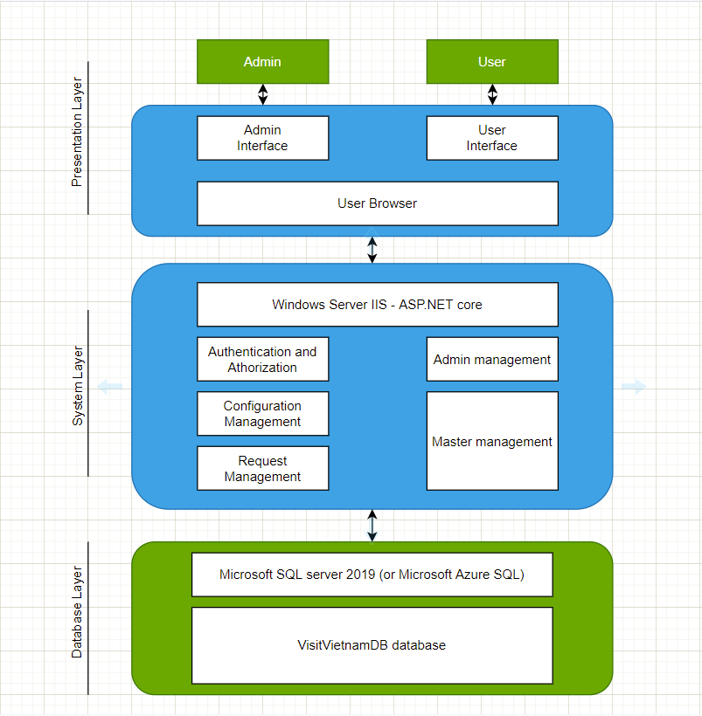

* 1. Design Model
     1. Use-case diagram
* This diagram shows the summary requirements of use case that already existed in Requirement Specification.

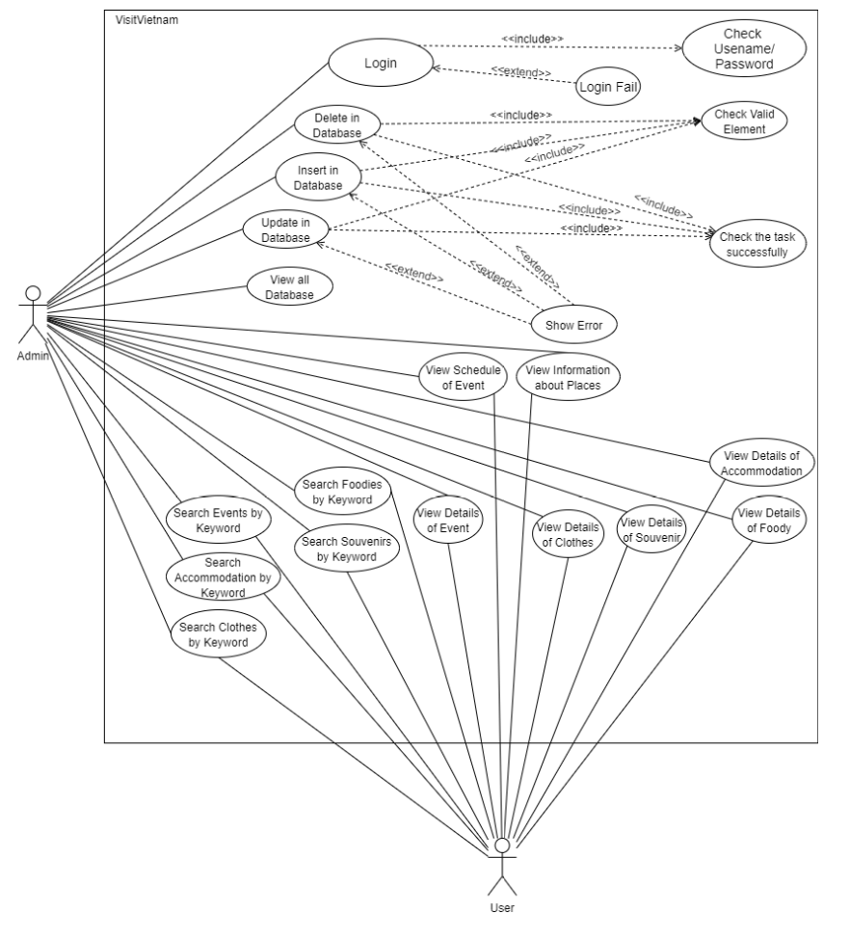

* + 1. Sequence diagram(X)

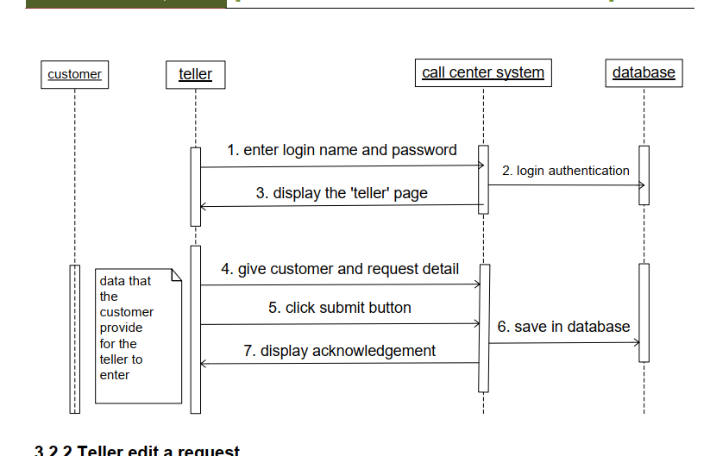

* + 1. Class diagram

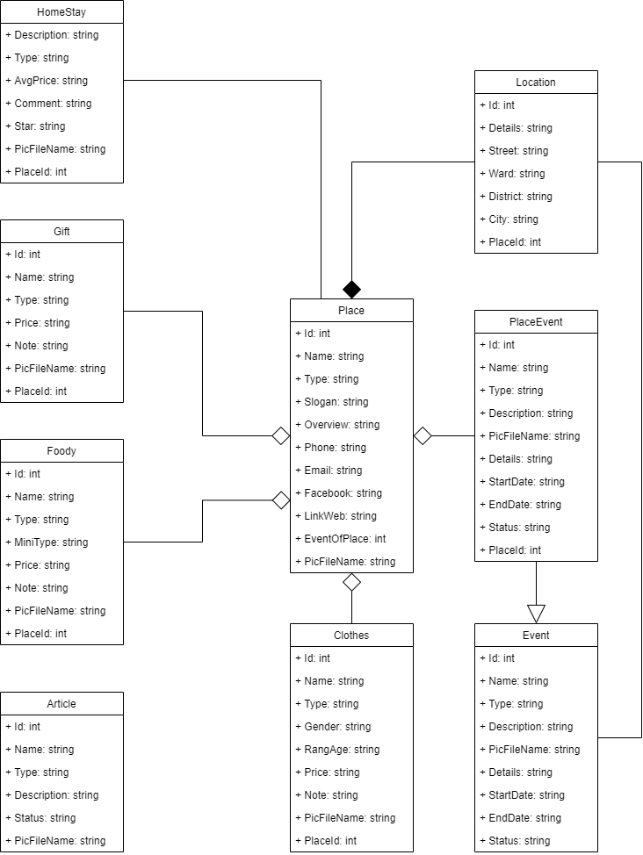

* + 1. Activity diagram(X)

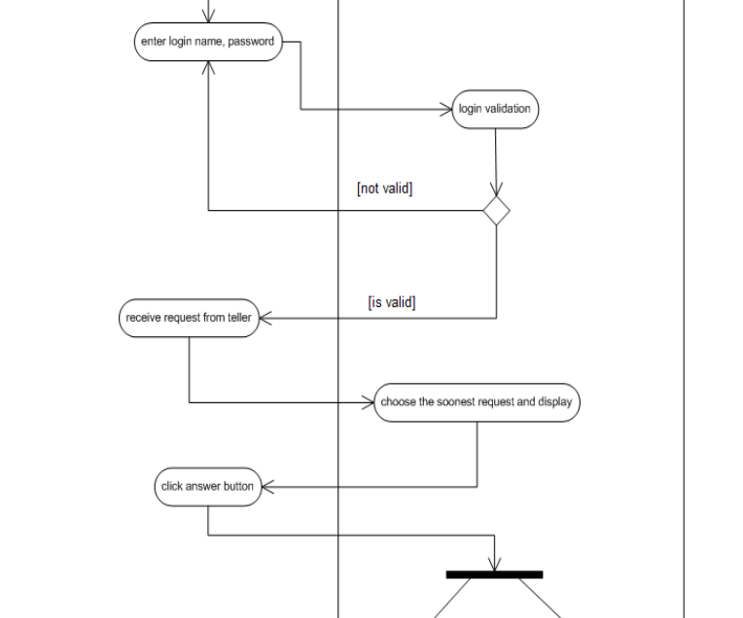

* + 1. State diagram(X)

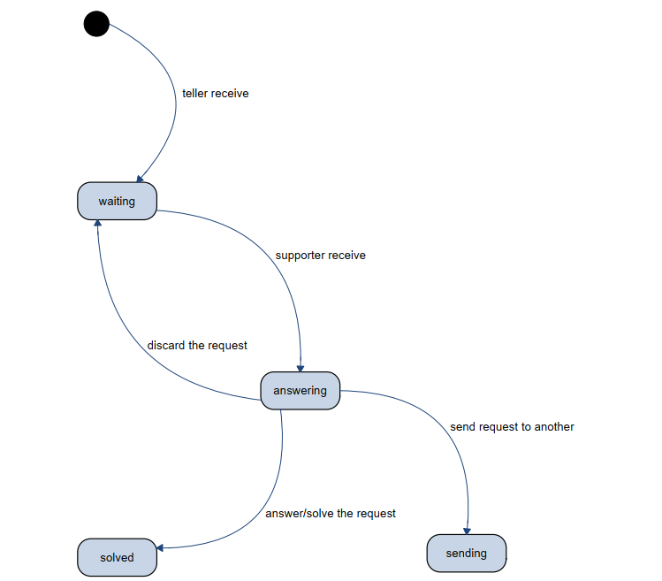

* 1. Initial Database Model
     1. Entity and relationship diagram

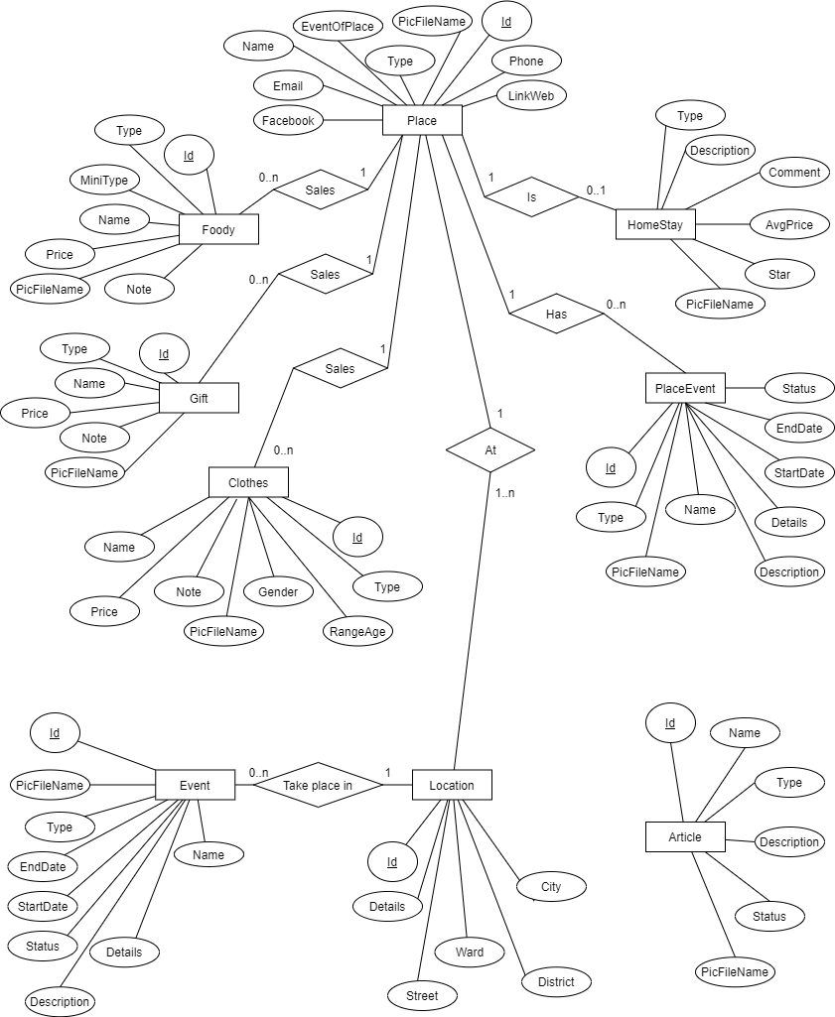

* + 1. Database schema



* + 1. Data object
* Provide below is a summary of the various data objects that make up the VisitVietnam System. Each table includes the attributes of each object, the data type for each attribute, the number of characters allowed for each field, and any other information that defines the field.

+ Article object:

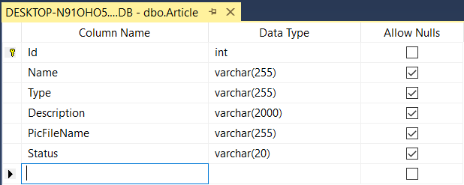

+ Clothes object:

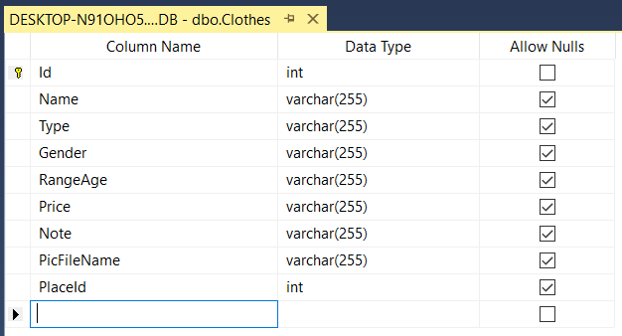

+ Event object:

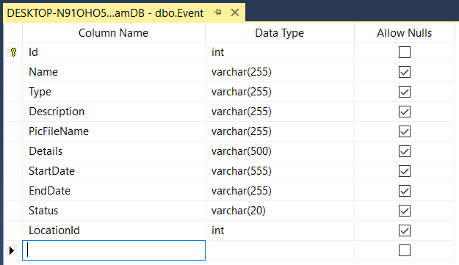

+ Foody object:

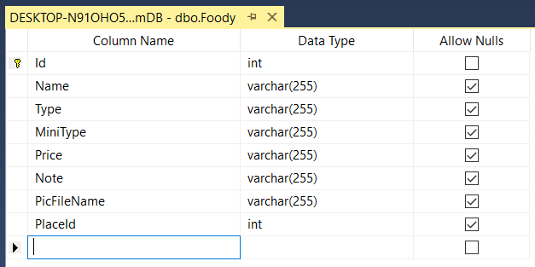

+ Gift object:

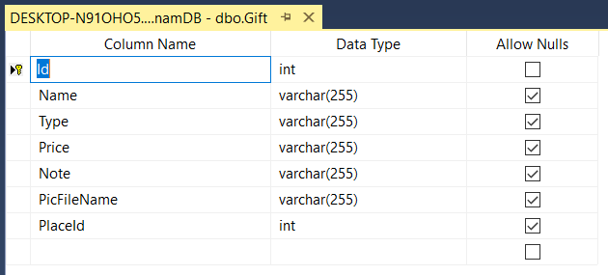

+ HomeStay object:

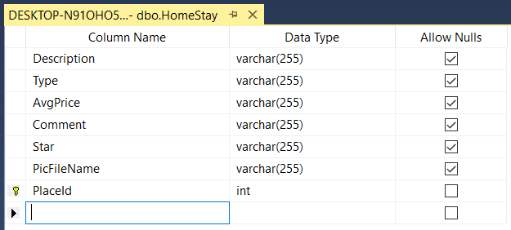

+ Location object:

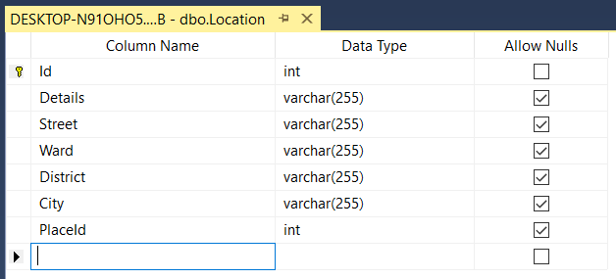

+ Place object:

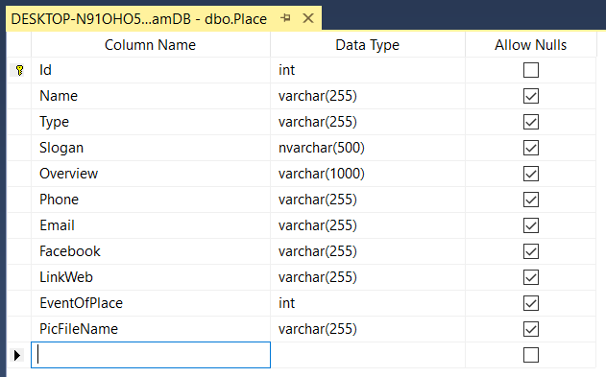

+ PlaceEvent object:

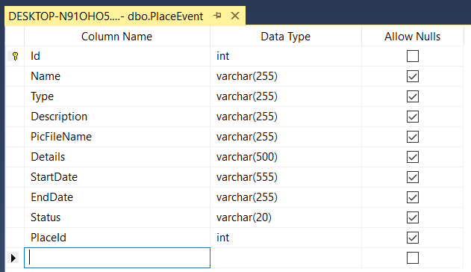

* + 1. Data dictionary

|  |  |  |
| --- | --- | --- |
| **Table** | **Description** | **Example** |
| Place | Contains the name of a place and its basic information, contact information and promotion information | + (Name, Type, Slogan, Overview, Phone, Email, Facebook, LinkWeb, EventOfPlace, PicFileName)  + ('Hoang Yen Buffet', 'Foody',  N'Hoàng Yến Buffet – Ăn đúng nơi, ngon đúng điệu',  'For a long time, Hoang Yen Buffet restaurants have become a familiar destination of gourmet in Saigon. With an extensive menu of over 60 lunch dishes and more than 70 buffet dinner dishes, the restaurant offers its diners a unique and exciting culinary journey. The dishes here are a combination of many different culinary styles and are also the enthusiasm of many experienced chefs.',  '02838233220', 'care@hoangyengroup.com', 'https://www.facebook.com/hoangyenbuffet', 'https://hoangyenbuffet.com/', '0', 'hoangyenbuffet.png') |
| Location | Contains detailed address and information from ‘street’ to ‘city’ | + (Details, Street, Ward, District, City, PlaceId)  + ('B3-27 Floor B3, 72','Le Thanh Ton','Ben Nghe','1','Ho Chi Minh','1') |
| Clothes | Contains the name of a garment, its genre, image and background information, along with where it is for sale. | + (Name, Type, Gender, RangeAge, Price, Note, PicFileName, PlaceId)  + ('Vay voan hoa co V cot no sau VU2501C','','Women','20-30','149000','','vayhoa.jpg','1005') |
| Foody | Contains the name of a food, its type, image and background information, along with where it is sold. | + (Name, Type, MiniType, Price, Note, PicFileName, PlaceId)  + ('Balut', 'Buffet', 'Egg', '30000', '', 'hoangyenbalut.png', '1') |
| Gift | Contains the name of a gift, its category, image and background information, along with where it is sold. | + (Name, Type, Price, Note, PicFileName, PlaceId)  + ('TEA-CAKE CARDS with animal images- 18X11.5CM', 'Gift', '8000', '', 'teacard.jpg', '1009') |
| HomeStay | If a place is used as a home stay. It will contain information, pictures, the average price of that accommodation | + (Description, Type, AvgPrice, Comment, Star, PicFileName, PlaceId)  + ('Cheap', 'Hotel', '450000', 'No Comment', 'five', 'anonymous.png', '1016') |
| PlaceEvent | When an event occurs somewhere, this will contain information describing the event, a picture and the time of the event at that place. | + (Name, Type, Description, PicFileName, Details, StartDate, EndDate, Status, PlaceId)  + ('MINISHOW TÌNH THÔI XÓT XA', 'Music', 'LAM TRUONG', 'tinhthoixotxalamtruong.jpg', '', '2021-05-01', '2021-05-01', 'Remaining', '3064') |
| Event | This is an event that happens everywhere, not a particular place, this will contain information describing the event, image and time of that event | + (Name, Type, Description, PicFileName, Details, StartDate, EndDate, Status, LocationId)  + ('Lunar New Year', 'Traditional', 'This is Description', 'hinh-anh-mau-thiep-chuc-mung-nam-moi-don-tet-dep-va-y-nghia-nhat.jpg', 'This is Details', '2021-05-05', '2021-05-28', 'Ended',’Null’) |
| Article | It can be an article or an article to review about Vietnam's cuisine, culture, and landscapes. It contains a description of what it is about | + (Name, Type, Description, PicFileName, Status)  + ('Vietnam Food Traditional', 'Event', 'Food is at the heart of Vietnamese culture and Vietnamese food is one of the most popular cuisines in the world as it mixes together a range of flavors and tastes. While street eateries are everywhere, as the city becomes more affluent, Vietnamese cuisine is going indoors. These days, there are a lot of local restaurants that provide quality and authentic Vietnamese cuisine. All Vietnamese dishes mentioned here will be listed with our recommended local restaurants. Please use this list as a resource and inspiration for your Vietnam holiday.', 'event_3.jpg', 'This is status') |

1. USER INTERFACES
   1. HOME PAGE

* Graphical user interface, website

  Description automatically generatedBy default, the system will display the home page with the introduction to the website. Admin will enter the username and password to validate before using the inside system. Users who have a linked website that can be access. Each of functions has more contact info to user comment about the system when have a problem or have a question.
* There are 4 functionals: event, shopping (clothes and gift), foody and stay. After accessing the website, users can experience for serving personal needs.
  1. EVENT PAGE
* The “Highlights” part: this place will summary which is hot event upcoming has the event named and short description about it. So, users can quickly view, and update travel their information.
* A picture containing graphical user interface

  Description automatically generatedEach of event has a time attached and the schedule of users will quickly arrange to suitable with that time.
  1. SHOPPING PAGE
* Graphical user interface

  Description automatically generated with low confidenceAbout this page, we will divide into two functions: clothes and gift, because we want to everything clearly and easy to find title which users want to find. We find the impressive store which based on user traffic on the Internet and visiting the main web store. In addition, we illustrate address, price…some contract related to store they search.
  1. FOODY
* A screenshot of a computer

  Description automatically generated with medium confidenceWe separate some kinds of food/drink to help users choose variety of things for solve food needs. Belike other structure show information, we have the name food, address where sell and illustration for easy to know what those foods is.
  1. STAY
* A screenshot of a video game

  Description automatically generatedWe have some types of places: budget hotel, hostel, homestay, villa…. When users click to choose one type which suitable with them show information include the name place, address and rating. It quickly helps the user find reasonable accommodation for themselves.

1. INSTRUCTION TO USE WEBSITE
2. SUMMARY
   1. DIFFICULTY
   2. DEVELOPMENT
   3. CONCLUSION
3. WORK ASSIGNMENT
4. REFERENCES